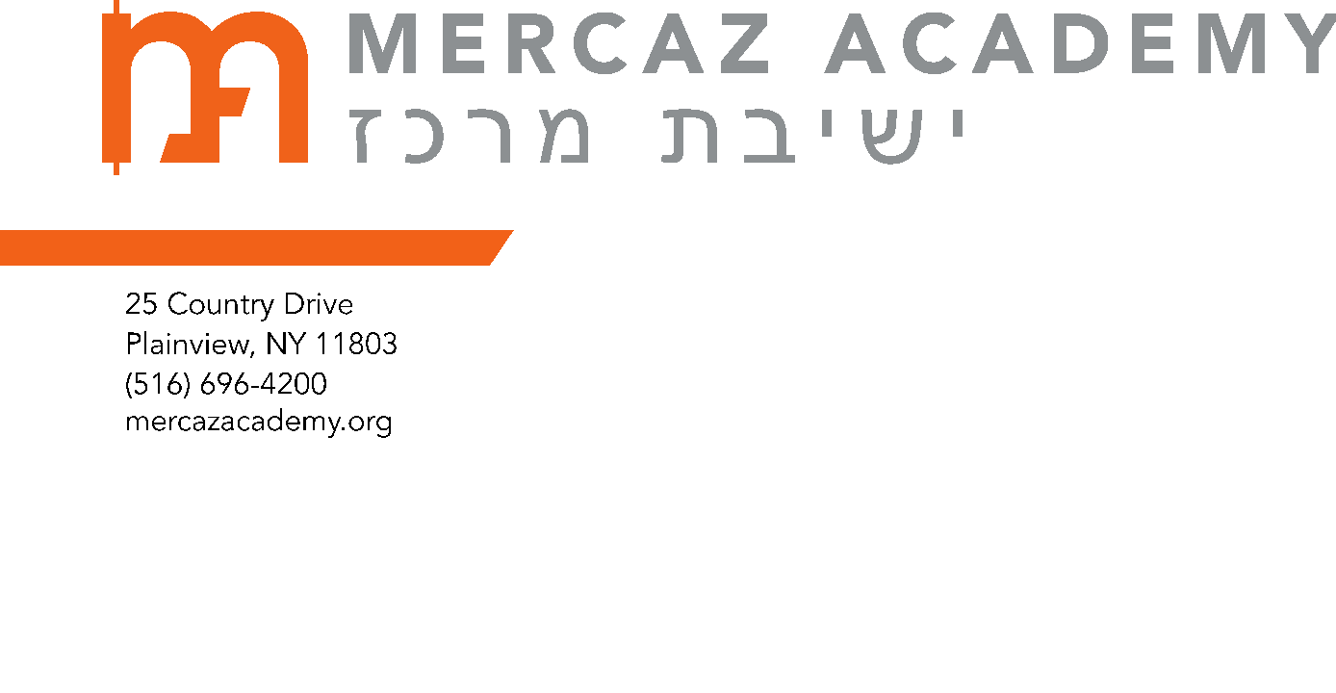
SAVE $1,000 OFF NEXT YEAR’S MERCAZ TUITION
Dear Parents,
This is a reminder about a unique opportunity for you to save up to $1,000 in tuition costs. To celebrate this spectacular first year for MERCAZ ACADEMY, we are publishing a one-time-only COMMEMORATIVE BOOK, which will be a keepsake for years to come. We invite you to contribute to this special publication and at the same time save up to $1,000 on tuition in either of the following two ways:
- You can place a Full-Page Business Ad for your own business or solicit ads from other businesses* (Full-Page Business Ads start at $1,000- see attached Business Ad Form) in the Commemorative Book. All Full-Page Business Ads are in color and include FREE electronic ads.

- You or family, friends, neighbors, businesspeople, etc. can add a celebratory greeting/message in The Friends and Families section of the Book (see attached form and pricing).

All of the above donations can be used towards the $1,000 offset.
Please contact Barry Helprin ( barryhelprin1@gmail.com; 516-695-4235) BEFORE you begin soliciting ads, to find out which businesses have already been approached and with any other questions you may have.
May we go from strength to strength.

*PLEASE NOTE: ads from food establishments MUST have supervision that is acceptable to Mercaz; the list of acceptable hashgachot is in our family handbook.

